Name: Marjorie Dewey
Country: Japan
Period: April-June 2013
Date Submitted: July 26, 2013

RECENT TRAVEL TRENDS

Japanese Outbound Travel Down in 2013: The Japan National Tourist Organization announced that the estimated number of Japanese overseas travelers in April 2013 was 1,237,000, a 12.3% decrease over April 2012, and 1,262,000 in May 2013 (-11.8%). The outbound figure decreased over the same month of the previous year for four straight months. The May Golden Week Holiday was divided into two holidays by three-day weekdays and it was not easy to take a long holiday for Japanese travelers. Also, the weakening yen value curtailed the number of overseas travelers. Although the number of visitors to South East Asia such as Thailand (+12.7%) and Vietnam (+13.4%) have increased, East Asia destinations have been showing a prolonged decrease.

Japanese Travel to U.S. Up 14% in 2012: According to the data released by OTTI, the total number of Japanese visiting the U.S. in 2012 grew to 3.7 million visitors, up 14% from 2011. Japan is the second largest overseas inbound market (behind the United Kingdom) and the largest overseas market in terms of spending. Japanese visitors to the U.S. spent $16.6 billion in 2012, up 12% over 2011. 2012 saw Japanese leisure travelers return to the U.S. in large numbers for the first time in a decade. All signs point to continued steady growth in 2013. Although the total number of Japanese outbound travelers has been declining in 2013, the decrease is largely due to the lack of demand for travel to China or South Korea resulting from ongoing political tensions. Tour operators report that demand is up for U.S. destinations which are now seen as a friendly and attractive alternative.

APRIL-JUNE ACTIVITIES

Inquiries
The following is a breakdown of inquiries to and sales calls made by the Japan office during April-June. A complete database of contacts and the nature of the inquiries is attached.

Total Trade Media Consumer/Other
Total 194 99 76 19

All 105 70 31 4
Arkansas 11 2 9 0
Illinois 59 15 40 4
Iowa 1 0 1 0
Kentucky 17 2 10 5
Louisiana 33 12 18 3
Minnesota 3 1 1 1
Mississippi 23 9 13 1
Missouri 5 3 2 0
Tennessee 53 40 8 5
Wisconsin 3 1 1 1

(The above totals exceed the total number of inquiries as some callers requested information on multiple states.)

Summary of Activities: Public Relations
Destinations in the Mississippi River Country were featured in the following media during April-June 2013.

Travel Trade:
- “Choose Chicago/United Airlines Media Luncheon Seminar”—Travel Journal Gateway, online site for Travel Journal subscribers, and Weekly Travel Journal; April 18 and May 6.

- “Choose Chicago/United Airlines Media Luncheon Seminar”—Wing Travel Daily E-newsletter and Wing Travel Weekly.trade weekly; April 18 and April 29

- “Illinois Driving Routes Revealed: Route 66 and the Great River Road”—Travel Journal, May 20; 3 pages. This project was sponsored by Illinois Office of Tourism

- “Educational and Technical Visits and Girlfriend Road Trip: Illinois”—Travel Journal, May 27; 2 pages. This project was sponsored by Illinois Office of Tourism.

Consumer Print:

- “Mind Voyage Chicago Program”—ANA Sky Channel Magazine, monthly inflight entertainment guide for All Nippon Airways international flights; guide to BayFM Mind Voyage program featuring Chicago that is part of the featured entertainment for ANA inflight from January-April 2013. The Japan Office assisted with planning and information for this project.

- “Return of America Rail Journeys: Chicago to New Orleans”—Frontline, biweekly print and online magazine for Japanese living in the U.S.; 7-page feature on Pullman service from New Orleans to Chicago, May 5.

- “Red Fishing in Louisiana”—Fly Fisher, monthly magazine for fly fishing enthusiasts; August issue published in June 2013; 6-page feature on southern Louisiana from visit in April 2013.

- “World Heritage Sites”—Chunichi Children’s Weekly, June 29; Weekly magazine for children produced by Chunichi Newspaper, a regional newspaper for the Nagoya-area (home to Toyota); Inclusion of Mammoth Cave National Park in special feature on World Heritage Sites.

- “Route 66 Driving Report”—Link USA, travel information web site; April-June; 10 pages on Missouri and Illinois as part of full driving report of route from California to Chicago. The Missouri and Illinois articles featured links to the MRC Japanese website.

- “Illinois Route 66 Guide”—Risvel Forest, June 30; 30 web pages; circulation 16,000 travel media and individual consumers, 108,000 page views/month. This project was sponsored by Illinois Office of Tourism.
http://www.risvel.com/magazine.php

Books/Guidebooks
- Globetrotter USA ’13-14: Most popular guidebook to the U.S.A; 109 pages on various Mississippi River Country destinations.

Broadcast:

- “Travel to the World’s Amazlng Views: Minnesota”—BS TBS, satellite channel of national network television; April 19. The program was supported by Meet Minneapolis and featured Minneapolis, Mississippi River headwaters and Lake Superior. This program will eventually be for sale via DVD.

- “Rainbow Town Oedo Wide Saturday”: June 8; Saturday afternoon Tokyo area local radio program hosted by Keishin Hayashi who visited Louisiana, Arkansas, Mississippi and Kentucky in May on the MRC media fam tour; 1-hour interview with CWWJ staff member Chie Usui on the visit.

- “Streetcars of the World: New Orleans”—BS Fuji, satellite channel of national network; May 23 program on New Orleans and the people who ride the streetcar from a visit in March 2013. The program will be re-broadcast 5 times through 2013 and 2014.

- “Streetcars of the World: Memphis”—BS Fuji, satellite channel of national network; June 20 program on Memphis and the people who ride the streetcar from a visit in March 2013. The program will be re-broadcast 5 times through 2013 and 2014.

- “Mezamashi Saturday-Top of the World Segment”: Fuji TV national network; highest audience rating of the three Saturday morning nationwide travel shows; 2 20-segments on Chicago aired on June 22 and 29 from visit in May. Places featured included: Millennium Park, Willis Tower, John Hancock Center, Wrigley Field, Architecture Cruise, Field Museum, Lou Malnati’s, Chicago hot dog vendor, jazz club, Harry Carey’s, Six Flags Great America. This project was introduced by the Japan Association of Travel Agents. This program will eventually be for sale via DVD.

Media Exposure
Travel Trade: 6 trade magazine articles ¥7,956,000 ($81,951)
Consumer: 3 web articles; 4 magazine articles; 1 guidebook ¥308,874,000 ($3,089,211)
Broadcast: 5 programs ¥23,401,800,000 ($234,129,340)

Value for year-Print: ¥511,664,250 ($5,648,608)
Value for year-Broadcast: ¥25,340,880,000 ($256,996,705)

The attached spreadsheet provides a complete listing of all publications and articles received during April-June 2013. Media values reflect a valuation of three times the standard advertising rates for publications/programming.

Mississippi River Country USA Japanese Website: A report of access to the Japanese website is attached. Visitors and page views continued to be significantly higher each month than in 2012 with the site averaging over 1,808 unique visitors per month. Access to the site for the second quarter of 2013 was up 11% over the same period in 2013.

Ongoing Media Projects: During April-June the office and MRC states assisted with the following media projects involving the Mississippi River Country region.

- Mississippi River Country Media Fam: Four journalists visited Louisiana, Arkansas, Mississippi and Kentucky in late May. The office coordinated the selection of the media, negotiated travel arrangements and escorted the tour. The journalists were especially pleased with the warm hospitality they received throughout the region. The visit has already resulted in a one-hour radio interview about the trip and a television special on blues music which will film in Memphis and Mississippi in July.

- Fly Fishing Magazine—Popular fishing magazine. They visited southern Louisiana in April for a feature on red fish fishing and touring the area. The office worked with Louisiana Tourism on detailed planning for the visit. The editors were so pleased with the quality and variety of places they visited, they expanded their planned 6-page article to two 6-page features. The first article ran in June and the second will be published later in the summer.

- Choose Chicago/United Airlines Media Luncheon: The Japan Office, United Tokyo office and HK Strategies (United’s PR firm) co-sponsored a media luncheon on April 16. A total of 15 media attended from leading women’s magazines, men’s magazines, travel trade publications and freelance travel writers. Choose Chicago and United both made presentations. Garrett Popcorn provided gifts for all attendees. Most of the media had almost no knowledge of Chicago, but all left expressing strong interest in doing stories in the next year. The travel trade press coverage was extremely positive and United staff were very satisfied with the event.

- Fuji TV: Japan’s largest commercial network filmed in Chicago and Galena in May for 3 segments on their Mezamashi TV (Top of the World) Saturday morning show. The show has the highest audience rating for its time slot and competes against two other popular travel shows. Illinois Tourism and Great Rivers Country sponsored the filming in Galena which included hotel and meals at The Goldmoor, a hot air balloon ride over the Mississippi River, shopping on Main Street, Irish dancing and farm-to-table dining at 111 Main. Two shows on Chicago aired in June and the Galena show aired in July. This project was introduced by the Japan Association of Travel Agents through Choose Chicago.

  - BS TBS: Satellite channel of Tokyo Broadcasting Corp. They are interested in filming an entire American Queen cruise from Memphis to New Orleans in Fall 2013 for a program on luxury cruising. The office discussed this project with the Memphis CVB at IPW and selected a November cruise as a good option. We will continue to follow up with the production company. This project was referred by Cruise Traveller magazine.

- J-COM Music Jungle: A Tokyo-based cable television operator and broadcaster. As a result of the recent Mississippi River Country media fam tour, they have decided to do two 30-minute programs on the Mississippi Blues Trail. One program will be on Memphis and one on Mississippi. The crew of three plans to visit in early July and requested assistance with hotel, filming arrangements and local Japanese guiding. The office worked with Mississippi Tourism and the Memphis CVB to set up the visit. The crew will film in Clarksdale, Cleveland and Greenville, Mississippi.

- City Living: A weekly free newspaper for young working women published by Fuji Sankei, a media conglomerate with newspapers, television, radio platforms. Chicago will be featured in the newspaper’s monthly travel page on July 5. The Japan Office was interviewed by City Living for content for this feature. The publication was one of the attendees at the Choose Chicago/United Media Luncheon in April.

- Co-Trip Chicago Guide: Japan’s most popular travel guidebook for young women published by Shobunsha. They are planning a first-ever Chicago-only guide to be published in late 2013 and sponsored by All Nippon Airways (ANA). The guide will feature restaurants, cafes, shops and museums of most interest to female travelers aged 25-35. The Japan Office held initial meetings with the editors in May and will work with them in the next two months to prepare for their visit to Chicago in September.

Summary of Activities: Marketing & Promotions

Visit USA Committee USTP10 Meeting
In March the Japan Visit USA Committee launched its first ever certification program for travel agents named the USTP10 (U.S. Travel Professionals 10) program. Ten key tour planners at the major tour operators were initiated into the program on March 14. The group meets once a month to study various new themes and ideas for developing and promoting tour product to the U.S. An advisory committee of senior executives at the participating tour operators was also formed to spearhead U.S. product development at the highest levels of the companies. The program is part of the U.S.-Japan Tourism Exchange Year. Choose Chicago was one of two destinations invited to make a presentation at the first meeting on April 25. The presentation on festivals and events was extremely well received, and several operators commented they have an entirely new view of Chicago as a result.

Kansai International Airport Travel Fair Kanku Tabihaku
The Japan Office participated as Mississippi River Country in this consumer travel fair held May 18-19 at Kansai International Airport serving the Osaka/Kobe area. It has become the largest travel fair in Western Japan. The show attracted 38,000 visitors over the two-day period. Choose Chicago Japan also participated in the show and conducted a consumer promotion with McDonald’s to boost attendance to the booth.

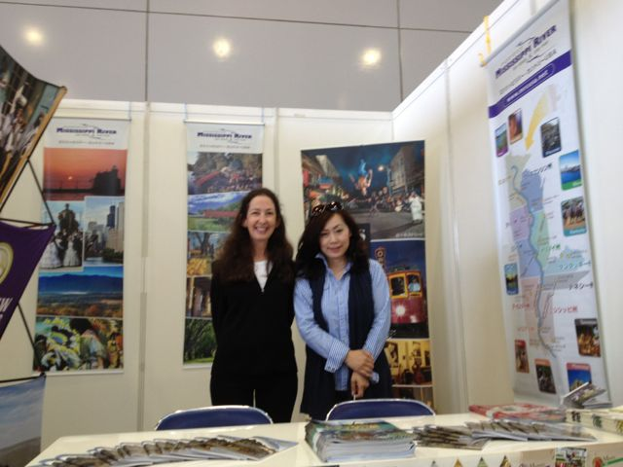

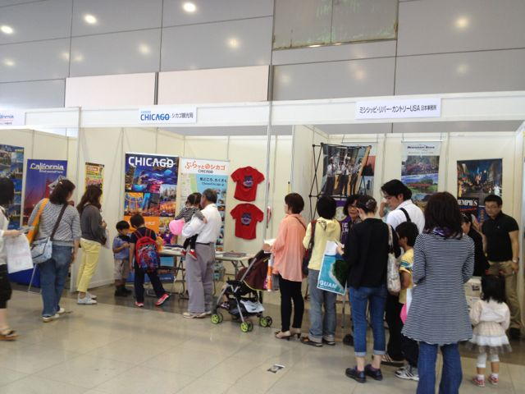
JATA and Brand USA In-Depth Seminars in Osaka and Nagoya
The two organizations coordinated a seminar for U.S. suppliers in Osaka and Nagoya following the Kansai Kanku Tabihaku event. Mississippi River Country participated in both seminars with a presentation on driving the Great River Road from St. Louis to New Orleans. The seminar attracted 42 tour operators in Osaka and 29 in Nagoya. There was particular interest in the driving itinerary and several operators expressed plans to develop product. All have been added to the database and the Japan Office will continue to follow up with them.

JATA and Brand USA In-Depth Seminars: Part 2
The two organizations announced plans for a second round of in-depth seminars for the travel trade in Tokyo to be held August 1-9. Each destination will have an opportunity to present once or twice during the week. Themes will be: World Heritage Sites/natural attractions in the West, Central/Midwest/South and East Coast; American City Life; American Theme Parks; Iconic Drives.

IPW 2013
This year’s IPW took place in Las Vegas from June 8-12. The number of Japanese delegates was large for the second year in a row. There were a total of 98 attendees from Japan: 69 leisure buyers (38 from Japan and 31 from the U.S.), 11 MICE buyers, 9 media delegates, and 9 VIPs from JATA and the Japan Tourism Agency. Marjorie assisted with appointments in the New Orleans booth and also attended the Japanese buyers breakfast on June 10. Details of appointments conducted at IPW are included in the inquiry report.

Japan Association of Travel Agents Annual General Meeting
JATA’s Annual General Meeting took place on June 19th. Marjorie attended and met with senior JATA executives and board members representing all of the major tour operators.

Delta American Queen and Memphis Tour Operator Fam
A group of 3 tour operators and one Delta escort visited Memphis in late June on the Delta and Memphis CVB 2-day tour operator fam. The primary purpose of the fam was to introduce operators to the American Queen and to update them on Memphis attractions. The group had VIP treatment on board the American Queen and a full schedule visiting Memphis attractions. As an immediate result of the tour, World Air-Sea Service has begun negotiations to send groups in 2014—southern route in the spring and northern route in the fall. WAS is the leading operator for high-end escorted tours for senior travelers and the president of WAS attended the fam.

*******

